**Install Minikube and kubectl**

1. Check the version of kubectl installed

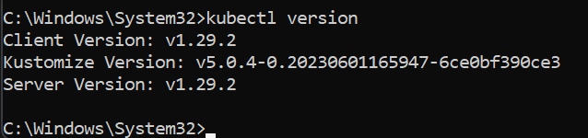

1. Install minikube. Go to minikube official website and click on the latest release of minikube

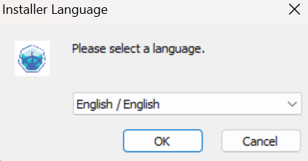

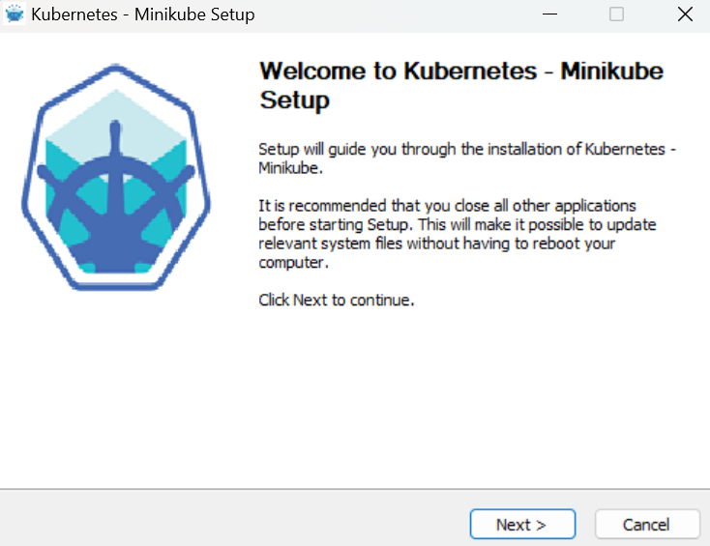

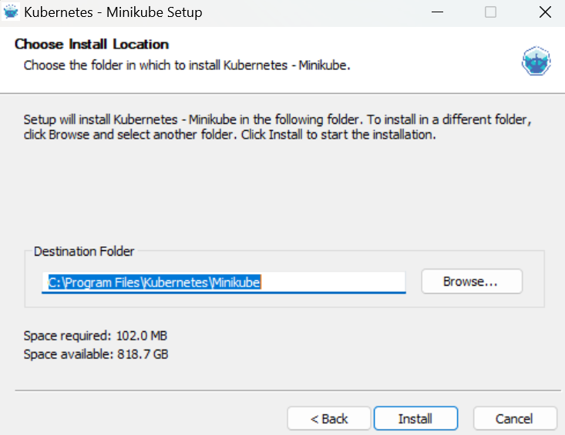

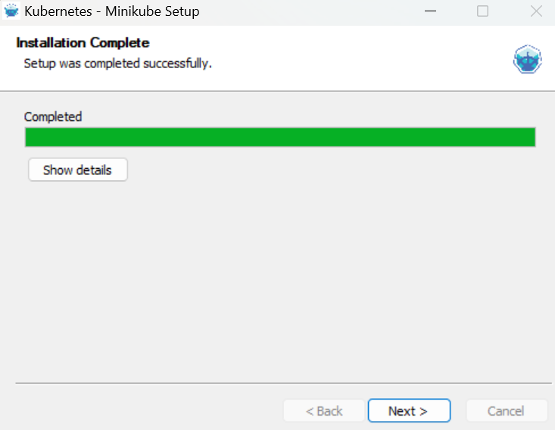

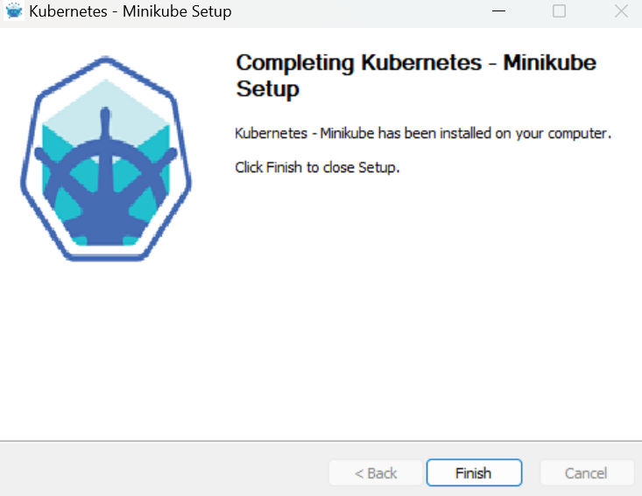

1. Check if minikube is installed: minikube version

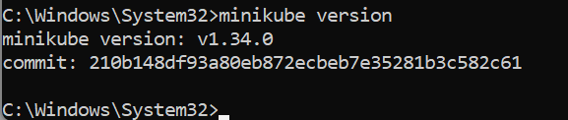

1. Minikube needs to be started with a driver. We use docker driver: minikube start --driver=docker

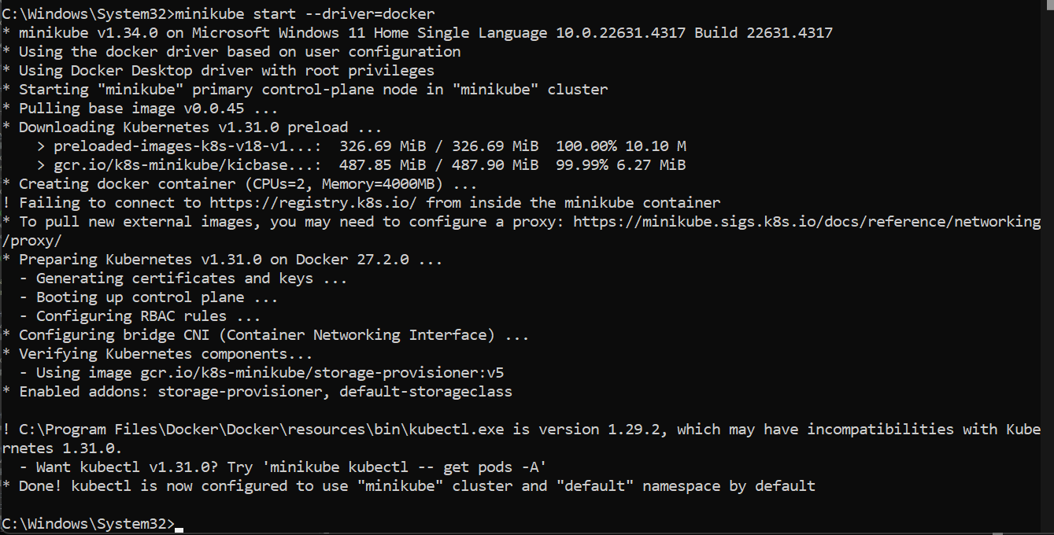

1. Docker ps: Check if the minikube container is running

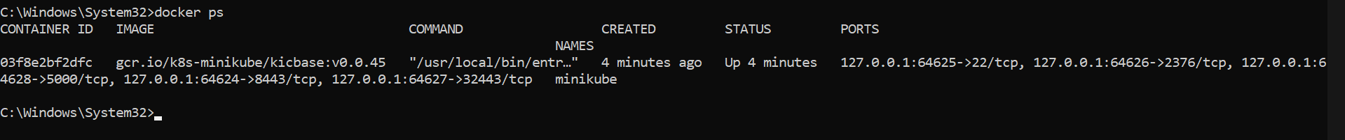

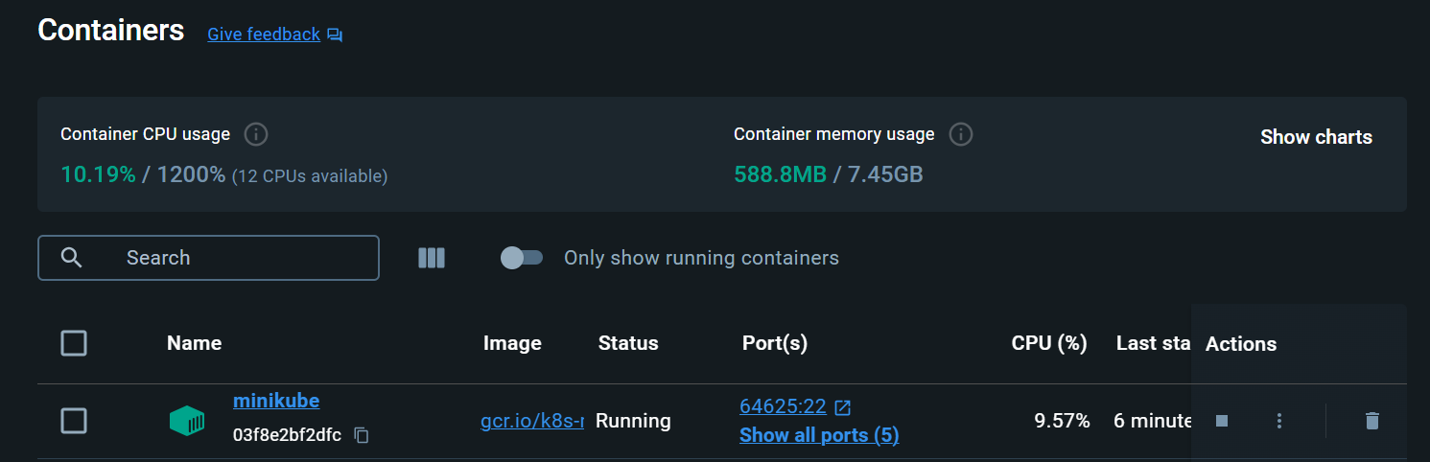

1. To check if control (worker) node is created: minikube status

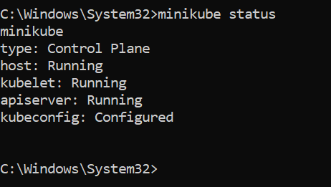

1. Running a pre-existing application (example nginx) on Kubernetes. Go to Docker hub-search nginx and click the official image

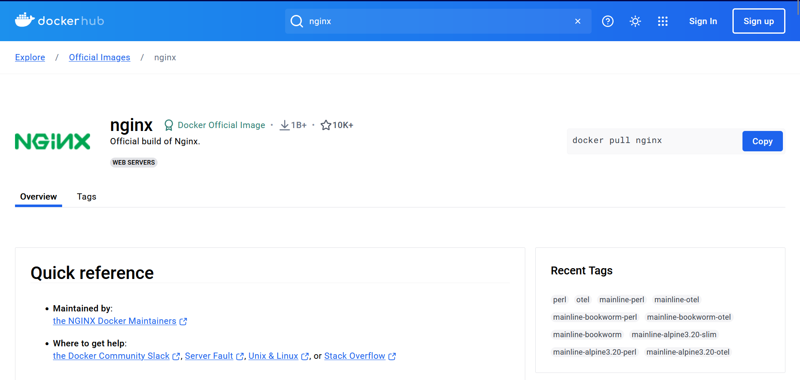

1. Now pull this image to create a deployment with Kubernetes

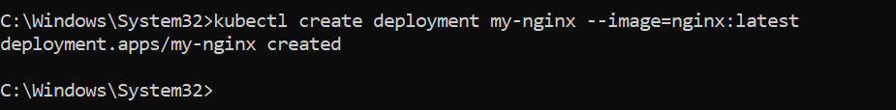

1. Check if the deployment was created

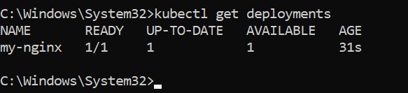

1. Check if the pod was created: kubectl get pods

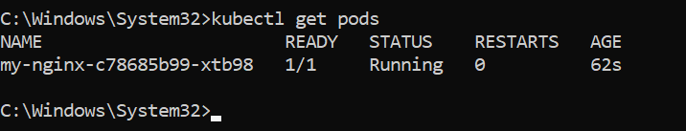

1. Expose the pod to minikube: kubectl expose deployment my-nginx --port=80 --type=LoadBalancer

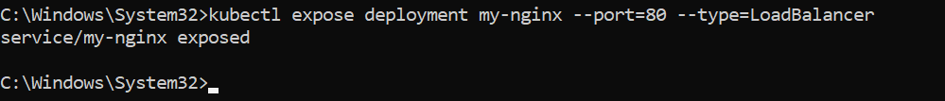

1. Check if your nginx service is running: kubectl get services

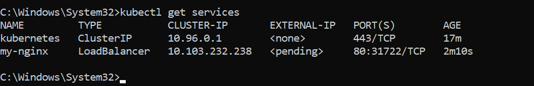

1. Link your service with minikube: minikube service my-nginx

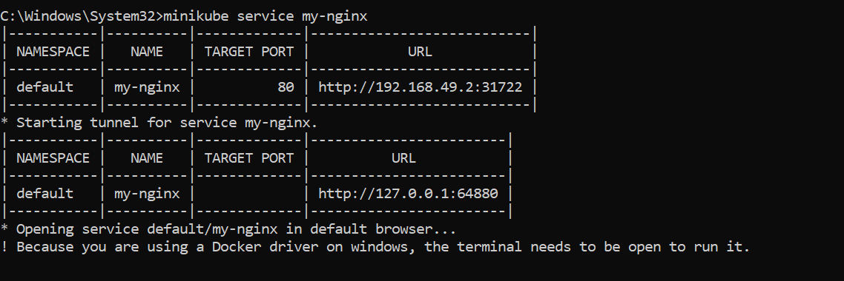

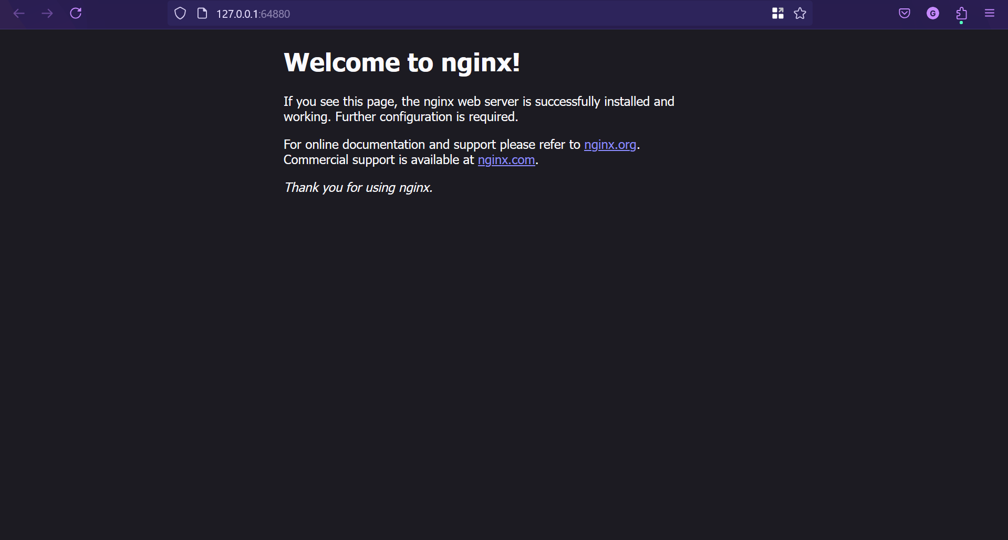

1. To delete the existing pods and container:

minikube delete

Run this and repeat everything here(follow everything above):

minikube start --driver=docker

1. Scaling on Kubernetes
2. Scaling nginx 3 replicas: kubectl scale deployment my-nginx –replicas=3



1. Check the number of pods: kubectl get deployments

Kubectl get pods

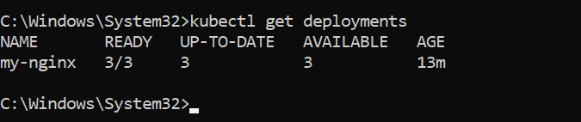

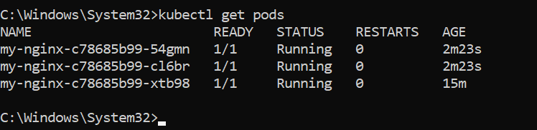

1. Scaling down: kubectl scale deployment my-nginx - -replicas=1

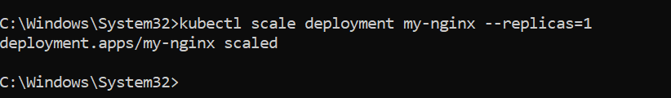

1. Check the no of pods: kubectl get deployments

Kubectl get pods

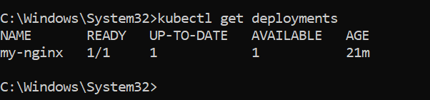

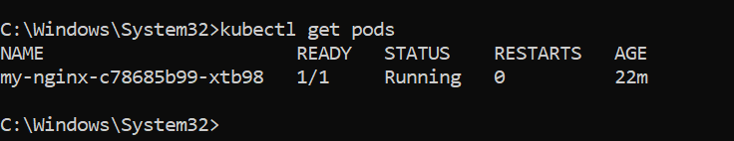

1. Running a hello world program…..